ONE VISION
SERVICES IMPROVEMENT
PLAN

JULY 1, 2017 TO JUNE 30, 2018

Mission:
The One Vision community supports individual choice by providing services that lead to greater purpose and independence.

Introductory Notes:

One Vision is a comprehensive service provider that offers the following CARF-accredited services throughout North Central Iowa:
1. Organizational Employment: paid contract work opportunities at the Kinney Lindstrom Center in Clear Lake and Northwoods Products and Services in Fort Dodge. (This service will be ending 09/30/2018.)
2. Community Employment Services: job development, job-site training, small group employment, and individual employment supports are provided in community businesses in Clear Lake, Fort Dodge, Humboldt, Webster City, Mason City, as well as many other small towns in the North Central Iowa area.
3. Community Integration: valued and meaningful day activities, including but not limited to, computer lab, volunteering in community organizations, recreational activities in the community or center, and arts and crafts.

Due to the HCBS Settings rule, One Vision has really been focusing on helping individuals who would like community employment to secure a position that interests them. Many individuals have been through Pre-Vocational Career Exploration, as well as Career Counseling. Initially, the intent was to discontinue the Day Habilitation services, as they were being held at the Kinney Lindstrom Center. However, after discussion with the HCBS Specialist, we chose to continue providing the services, as long as we were providing several options of things to do outside of the center-based setting.

We collect most of the data for the Service Improvement Plan on a yearly basis. However, some data is collected every six months. Some of the data is needed in the middle of the reporting period for other reports required by different agencies.

One Vision’s Strategic Plan is in the process of being updated. As part of the Strategic plan update the Service Improvement Plan will be reviewed.

Progress on trends and actions identified in the 2017---2018 services improvement plan report

Characteristics of Persons Receiving Services:
One Vision served 215 individuals in day / work services this year, primarily in the 18-40 year age group. More specifically, there were 0 individuals in the 3 and under age category, 3 between the ages of 4 and 17, 97 between 18 and 40, 61 between 41 and 65, and 7 that were 66 and over. There were 115 males and 100 females.
Progress: No concerns or problems were noted in the characteristics of individuals receiving services.

Annual Review of Incident Reporting Procedures:
No patterns of concern were identified upon review of incident reports from the day / work service areas. Leadership staff in the day / work areas review incident reports in Therap, and if concerns are noted, they will be the ones to follow up on them. (Therap is the electronic health record chosen for all documentation organization-wide. These reports are known as General Event Reports – GERs – in the Therap system.)
Progress: Incident reports (GERs) were monitored by area leadership. There were no concerns, trends or problems identified. There was one incident reported during this time period not reviewed by leadership. The incident resulted in a minor scrap by equipment while on the job. Incident reports will continue to be reviewed by the area leadership. If any trends or concerns are noted, leadership staff will follow up.

Annual Review of Complaints and Grievances:
No grievances were filed during the past year.
Progress: No problems or concerns were noted in this reporting period. If a grievance is filed, area leadership will review the issue, and address it accordingly.

Specific Program Area Goals:
Participation in Organizational Employment Services in the work center has continued to decrease. With the new rules regarding employment services that went into effect 05/04/2016, the focus has been on helping individuals search for and obtain community employment. The plan is for Organizational Employment Services to be finished and discontinued by 09/30/2018.
Community Employment Services has grown as referrals increased with the new rules. People have found jobs that they enjoy, and receive job coaching as needed to ensure continued success. Small Group Employment is still an option for those who choose to participate in that service.
Community Integration Services went through a bit of a change with the intention to discontinue the service. Program participation slowly decreased and was down to just a couple of individuals at one point. It was determined that for those individuals who would be losing Organizational Employment, not all of them would want to, or be able to, participate in Community Employment, but would still want something to do during the day. CIS became an option for those people. By continuing to provide a number of activities that people are interested in outside of the campus setting, we have been able to keep this program going.
Progress: It is anticipated that OES numbers will continue to decrease (and CES numbers will continue to increase) as we help people find meaningful jobs in the community. OES will be complete by 09/30/2018. CIS will maintain the current level of service.

Review of Satisfaction:
Individuals in the Pre-Vocational, Small Group Employment, Community Employment, and Day Habilitation areas were surveyed regarding their satisfaction with services, as well as families / guardians / responsible parties of those individuals, funding agencies, and employers who utilize our programs. Satisfaction with One Vision services remains high, as seen in previous years.
Progress: Overall, no major concerns were noted in the survey responses. There were a couple of negative comments made that were not related to the work / day areas of One Vision’s services, but those are being addressed as well as we can (comments were made by an anonymous responder).

CHARACTERISTICS

I. Characteristics of persons receiving Day/Work services:
Total number of individuals served: 215

Ages of persons we serve:
3 and Under | 0
4 – 17 Years | 3
18-40 Years | 97
41-65Years | 61
66 and Over | 7

Sex of persons we serve:
Males | 115
Females | 100

Annual Review of Incidents:

Incident reports are written for a variety of reasons. Reasons include, but not limited to: when individuals supported have injury or potential for injury, require first aid, have a mark or injury of unknown origin, falls, seizure causing a fall or injury, near miss/potential for incident, medication error, serious behavior problems, death, physical injury whereby they are seen by the physician or receive emergency room treatment, if law enforcement are called or needed, for emergency mental health treatment, allegations of abuse, neglect, exploitation or (in extremely rare cases) restraint. Incidents involving individuals supported are recorded in Therap, the electronic documentation system utilized by OV for individual records. Recording of each incident captures identifying information of the individual, specific location of incident, whether it was observed or discovered, type of incident, cause, what happened prior, description of incident, summary of what happened, immediate actions taken, corrective actions taken, plan for future corrective actions, persons/entities notified of the event, review and follow-up comments. Major incidents are submitted via the Critical Incident Report Form to the respective Managed Care Organization (MCO), Department of Human Services (DHS) and Department of Inspections and Appeals (DIA).

Each incident involving a person supported is reviewed by leadership staff and the individual’s team. Each month, the Executive Leadership Team reviews and analyzes the recorded incidents on both individuals and staff for trends and patterns of concern. Follow-up is completed on all incident reports to identify a root cause and determine a plan to reduce the risk of similar incidents in the future. Follow-up may include, but not limited to, providing staff training, educating the person supported on safety measures, determining how the person received the mark or injury of unknown origin, fixing a health or safety concern, or documenting the outcome of the emergency room visit or doctor’s appointment.

There were 65 incidents recorded from July 1, 2017, through June 30, 2018 in the work and day service programs. Follow-up was completed on all but 1(one) incident report. Our goal is 100% follow-up on incidents. Follow up was completed 98.5%. Follow-up is critical to our quality improvement process on incident reports. Leadership staff are responsible to review follow-up closely and ensure that follow-up has been completed. There were no sentinel events to report from July 1, 2017, through June 30, 2018.

Employee incident reports are written if an employee has an injury or potential for injury. Incident information on staff is recorded via an online form and data is sent to the Human Resource Team for follow up and analysis.

Annual Review of Complaints:

There were no formal grievances filed in the reporting period of July 1, 2017, through June 30, 2018. When individuals bring concerns to staff, they follow up on the concern and the issues are taken care of at the lowest level of the organizational chart whenever possible. Our goal is to always try and resolve complaints and issues at the lowest level so formal grievances are not needed or necessary. The key to resolving issues and complaints at the lowest level is listening, being flexible, and always viewing the individuals we support, parent/guardians/relatives, as our most important customers.

Individuals receiving services freely converse with the Chief Executive Officer (CEO), Regional Directors, and other staff in any setting they choose. Throughout the year, individuals freely call leadership staff when they have concerns or questions.

The Quality Leadership Team shares a satisfaction survey yearly with individuals receiving services and families. If the individuals or families identify themselves on these surveys, and there are concerns, the Quality Leader shares the information with staff who works closely with the individual or family so that follow-up can be done to help correct the situation.

PERFORMANCE ANALYSIS
OF VILLAGE SERVICES

I. Organizational Employment Services:

A. Effectiveness Indicator:
40 individuals increased their total wages. Our goal was 40. We met this goal. Over the past year, many individuals have continued to either have their days reduced or funding was dropped. Individuals continue to look for employment in the community and no longer are attending the Day Services program. This service (Organizational Employment) will be ending October 1st. There will be no new goal.

B. Efficiency Indicator:
20 individuals increased their overall productivity rate. Our goal was 25 individuals. As the service of Organizational Employment will be ending October 1st, there will be no new goal.

C. Service Access Indicator:
The goal is that after being funded, the individual will start organizational employment within 30 days. The goal was 95%. The goal was accomplished at 100%. As of 2017, the decision was made to no longer accept any new individuals into the pre-vocational program. This is due to this service ending in the near future. There will be no new goal.

D. Satisfaction from persons served and other stakeholders:
See section on satisfaction with One Vision services.

E. Extenuating/influencing Factors:
There was no down time for persons served as we had
adequate work for persons served. Funding for many
individuals continue to be cut or reduced.

II. Community Employment Services:

A. Effectiveness Indicator:
- Individual Employment Supports: 17 individuals have maintained employment in the same community business for at least one year in the Clear Lake and Humboldt area. Our goal was nine persons. Goal should be continued at 17 for coming year.

- Small Group Employment: The number of individuals involved in Group Employment increased by 4. Our goal was an increase of four for the reporting period. We will change goal to increase the number of individuals working in Small Goup Employment to 5 for the next reporting period. As Pre-vocational funding is ending, the emphasis will be looking for more Small Group Employment opportunities.

B. Efficiency Indicator:
- Individual Employment Supports: It took an average of 60 working days or longer from acceptance to service for individuals to obtain placement in a job in the Clear Lake and Humboldt area. Goal was 60% so was met. After review of the goal, and discussion with community employment staff-a lot depends on the service that the individual is requesting. As each individual is different, some placements may take as long as 3-4 months-again depending on the service and some of this out of our control. Will change the goal to no more than 90 days.

- Small Group Employment: five out of five contracts in the Clear Lake/Mason City area for group employment have revenue that exceeds expenses. Our goal was 100% and we achieved it. Goal will remain the same. We do now have 7 small group employment sights. All of them have revenues that exceeds expenses.

C. Service Access Indicator:
The goal is after being accepted for the service, placed on the waiting list and when there is an appropriate service opening, the individual will start community employment services within 30 working days 95% of the time. Our progress was 90%. Continue goal at 95%.

D. Satisfaction from persons served and other stakeholders:
See section on satisfaction with One Vision services.

E. Extenuating/influencing Factors:
More jobs in the community are always needed to meet the needs of those who are ready to work in cluster sites in the community.

III. Community Integration:
A. Effectiveness Indicator:
All RCF-ID homes located on the campus of One Vision as well as the Ralph Schroeder Group Home, have now closed. These individuals now live in homes in various communities in North Iowa and are encouraged and supported to participate in activities in their home communities. It was our intention that our Day Habilitation program based out of the Kinney Lindstrom Center would end however, during the past year more and more individuals, both those we currently support residentially as well as those new to One Vision, were expressing interest in participating in the Day Habilitation program. We now support sixteen individuals based out of the Kinney Lindstrom Center to participate in community activities of their choice. Our goal was for individuals to participate an average of 35 community activities per month or 420 total community activities. Individuals participated in an average of 32 activities per month with a total of 334 total community activities. Goal will continue.

B. Efficiency Indicator:
The individuals involved in Day Habilitation services on campus in Clear Lake have volunteered in the community for 31 events totaling 154 hours. The goal was set at an average of 110 volunteer hours per month, a total of 1,320 volunteer hours for the reporting period. We did not meet this goal. As more volunteer opportunities are acquired we are hopeful these numbers will increase. Goal will be set at 35 volunteer activities and 200 volunteer hours.

C. Service Access Indicator:
After being accepted for service, put on the waiting list and there is an appropriate service opening, the individual will start the One Vision Day Habilitation service within 30 working days. Our goal was 95% and we met this at 100%. Since our Day Habilitation program is growing, we are in the process of hiring more staff to continue to increase the number of individuals we can support in the program. Change goal to 100%.

D. Satisfaction from persons served and other stakeholders:
See section on satisfaction with One Vision services.

E. Extenuating/influencing Factors:
The Day Habilitation staff hold monthly meetings with the individuals who receive this service to determine available community and volunteer activity options. Interest is noted and monthly schedules are created with the information gathered from the meetings. The days of the week as well as times scheduled vary so all individuals have the opportunity to participate. This “schedule” is flexible and individual choice is always followed. When individuals choose to not participate in the original chosen activity, alternate activities are chosen by the individual.

SATISFACTION WITH
ONE VISION SERVICES

Satisfaction Surveys:

Gathering input from the stakeholders of One Vision was completed in many ways. Satisfaction surveys were sent to funders, employers who utilize One Vision Work Options/contract employers, families and guardians, and many individuals receiving services in a variety of employment and community services. Also, One Vision leadership reviewed individual written ISP Plans to ensure satisfaction. Individual interviews were also used to gather input from persons receiving services, including visits to people’s homes. Progress reports on outcomes were completed monthly and a review of the Medical Record was completed. The Vision team, a group made up of self-advocates meets regularly to share their opinions with the Board and Administration. This group is mostly comprised of individuals we support in North Iowa locations. HCBS completed a focus review onsite for all non-residential sites and were very impressed by the staff, the programming, and the quality of life for persons receiving services that were observed.

Information on the satisfaction surveys are collected via a score or written comments/suggestions. Each statement on each satisfaction survey can be rated by a choice of a graduated score such as Strongly Agree, Agree, Neutral, Disagree and Strongly Disagree.

I. Family/Guardian Satisfaction with Services:

Surveys were completed by 25 parents/guardians/other relatives from various cities around North Iowa for individuals who are in a variety of employment and community services. Our overall score is 4.31 as compared to 4.4 last year.

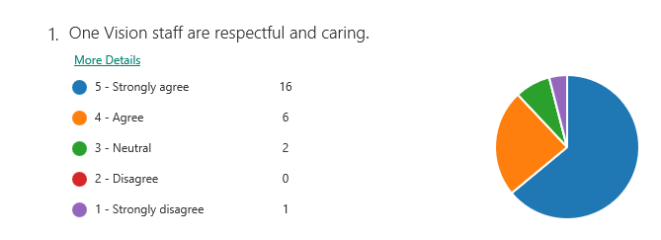
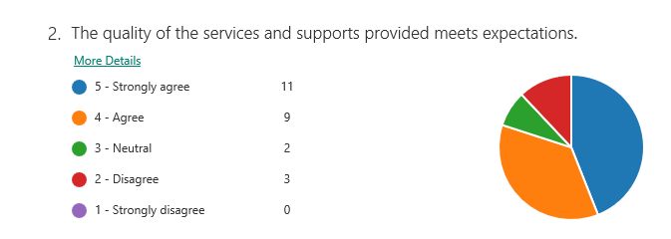
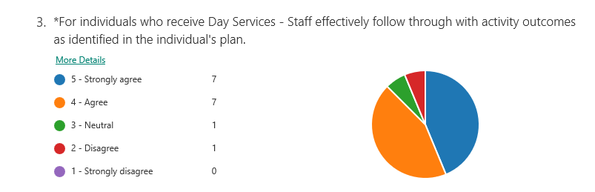
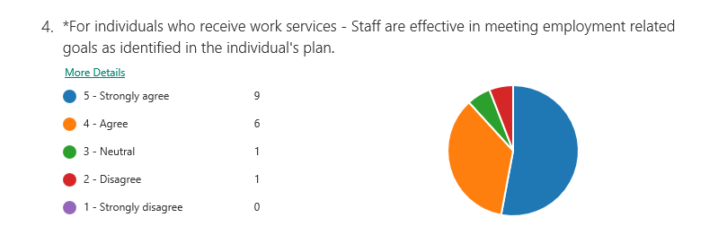
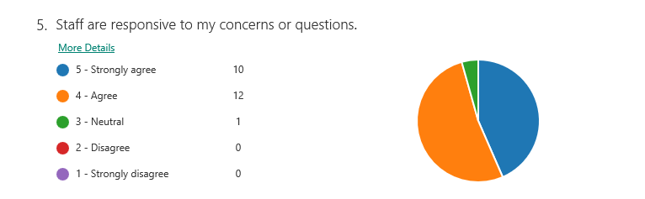

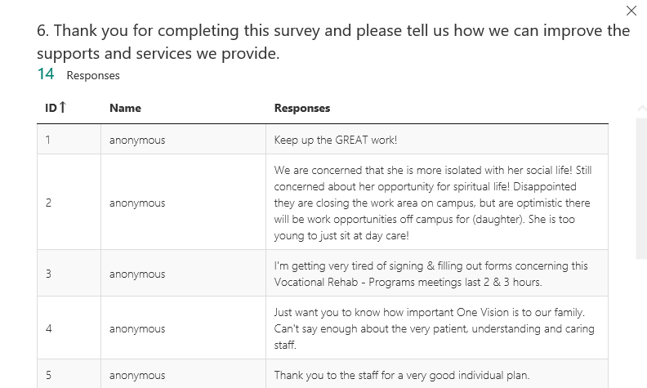
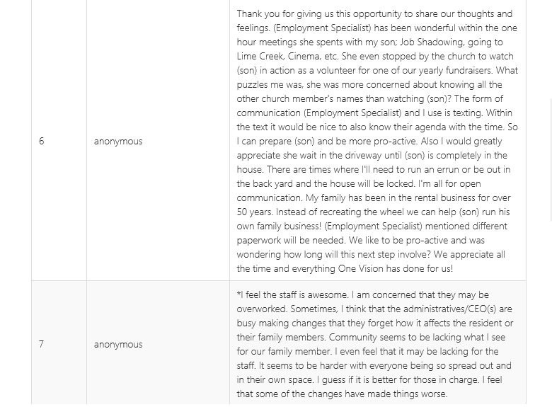
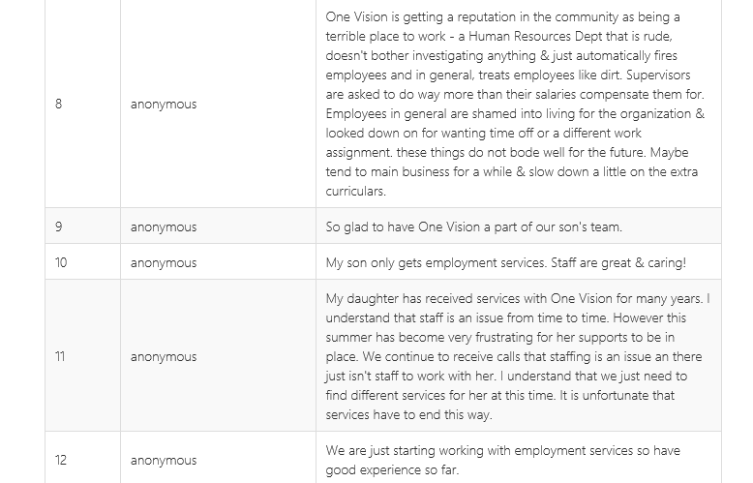
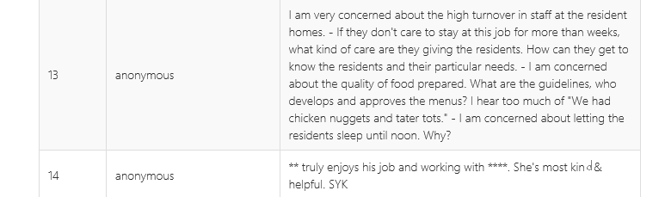
One Vision is working to address the concern of community activities offered. Each leadership staff per home is now required to work 24 hours a week in the home to allow extra staffing for individual choice of community events. The concerns noted by respondent #6 were addressed with that staff’s supervisor immediately. One Vision’s CEO was made aware of the concerns noted in respondents #7 and #8. Staff turnover, including leadership, continues to be an area of concern and is being addressed by hiring a full-time person responsible for recruitment.

II. Funding Agencies Satisfaction with Services:
Due to Managed Care Organizations taking over the funding of Medicaid services as compared to all the various counties of funding in previous years, only three funding agencies returned surveys. Our overall score is 4.19 as compared to 3.49 last year.

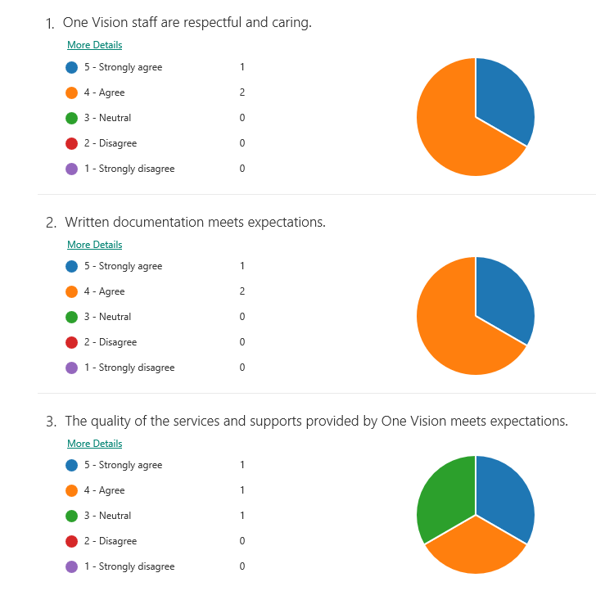
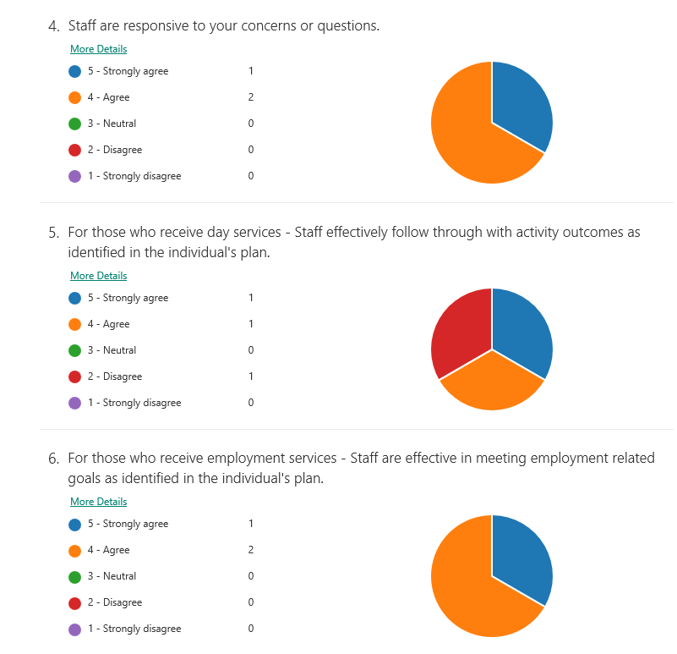
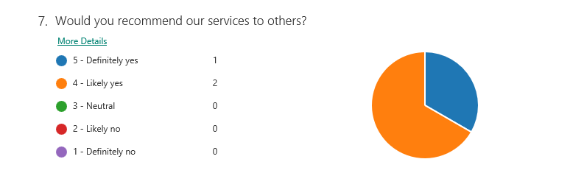
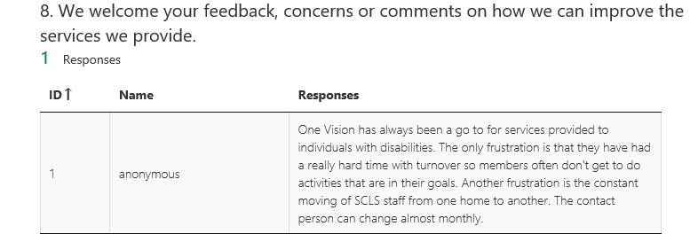

As previously noted, staff turnover, including leadership, continues to be an area of concern and is being addressed by hiring a full-time person responsible for recruitment.

III. Summary of Satisfaction Surveys from Employers

Due to the reduction in contract work done at One Vision, only 2 contract employers completed surveys. Our overall score was 4.6 as compared to 4.48 last year.

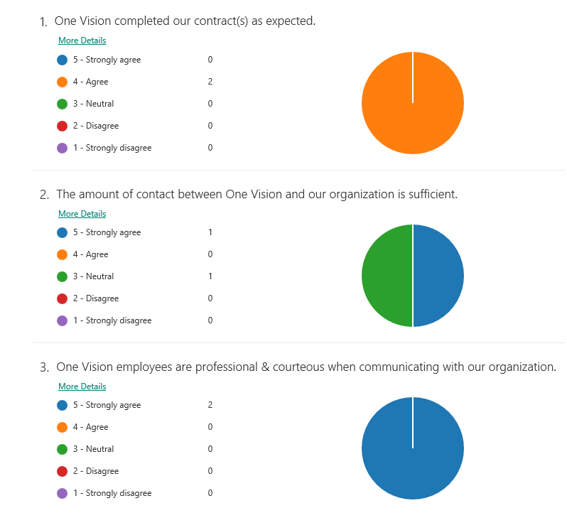
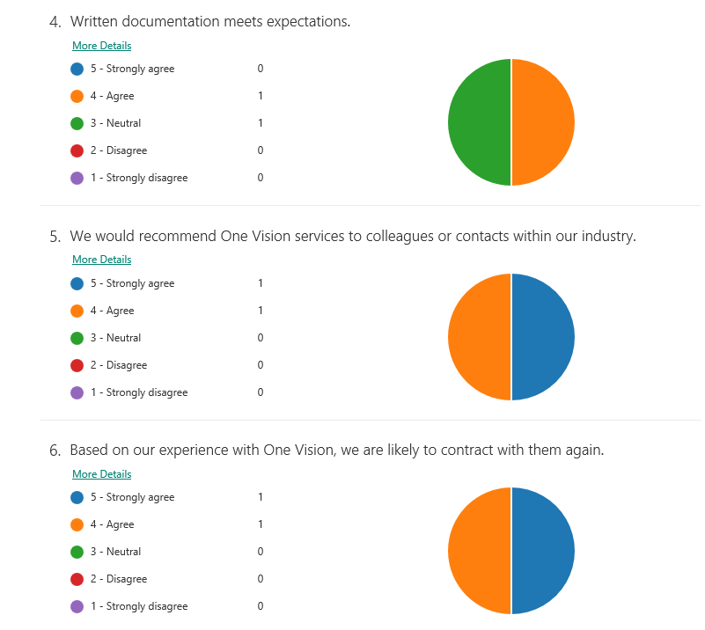
There were no additional comments or concerns indicated on the two survey responses.

IV. Persons Receiving Services Satisfaction:

Information about the satisfaction of persons receiving services is gathered in many ways. Several staff members from the Administration meet monthly with a group of self-advocates. This group, called “Visions” team, discusses concerns that individuals have and advises the Administration on current issues.

Team Coordinators review most annual Individual Support Plans each year. At the Plan meeting, the preferences and desires of the individual are discussed and noted in the Personal Focus Worksheet in Therap and plans are made to accomplish certain things in the coming year. The satisfaction level of the person concerning his/her outcomes is also be assessed and expressed during the meeting.

The Human Rights Team reviews Behavior Intervention Plans to ensure individual’s rights are not restricted without due process and sound reasons. Some individuals served come to the meetings where their plan is being discussed. Human Rights Team members follow-up and check on the Behavior Intervention Plans regularly, to monitor that plans are implemented as written and rights are respected.

Satisfaction surveys from a sampling of individuals who are involved in the different employment and community services offered by One Vision are also completed and below are combined data and statistics from these surveys.

16 individuals completed surveys with assistance from support staff. Our overall score is 4.03 as compared to 4.28 last year. OV leadership works hard to address individual’s needs and wants as they are made aware of them through a variety of ways such as interviews and observations.
