The Children’s Autism Center is Moving!

Due to the construction on One Vision’s main campus, the Children’s Autism Center will be moving to a new location effective Monday, September 10th!

WE WILL NOT HAVE SERVICES ON FRIDAY, SEPTEMBER 7th or MONDAY, SEPTEMBER 10th DUE TO PACKING AND MOVING.

1020 Buddy Holly Place
Clear Lake, IA 50428

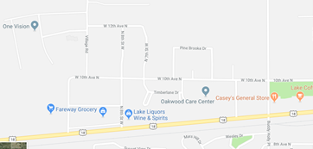
NEW LOCATION

We will have an informal open house for Families to tour our new facility throughout the week of Sept. 10th during normal business hours.

Thank you for your ongoing support and patience during this transition! If you have any questions please feel free to contact our Clinic Manager, Ashton Tucker, at 641-355-1201.

