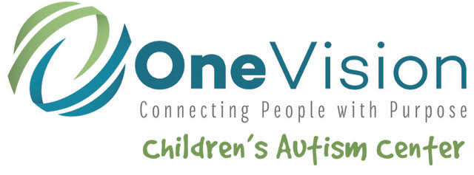
WELCOME to the One Vision Children’s Autism Center (OVCAC)!
We seek to provide support, education, direct service, and HOPE for children and their families with autism through the implementation of Evidence-Based Practices; the provision of Family Support and Advocacy; and Collaboration with other professionals, agencies, and stakeholders.
The OVCAC is dedicated to improving the lives of the children and families we serve. We strive to provide a “seamless” continuation of services from the first time you enter the OVCAC, throughout your child’s treatment, and on to generalization of skills to the child’s environment. Depending upon the child’s individual needs, this might include working with other professionals, such as a speech pathologist, school districts, AEA, mental health, etc. in conjunction with parents.
Services through the OVCAC are individualized to meet the needs of each child. Just as no two children with autism are alike, no two treatment plans are alike. Progress monitoring is conducted for each child through data collection and analysis to determine the effectiveness of treatment and whether a child’s goals are being met. Staff receive weekly supervision to assess progress and update goals as necessary. Parents are also informed of their child’s progress through quarterly reports. Parents have the opportunity to receive training on skills they can use with their children at home to increase the likelihood that treatment goals will be met even sooner.
GETTING STARTED:

We look forward to meeting you and your family and are glad you are here at the OVCAC.

ENROLLMENT PROCESS:

Step 1: Does your child have a formal diagnosis of an Autism Spectrum Disorder?

- YES! Move to step 2.

- NO. You will first need to schedule formal diagnostic testing. There are currently several places in Iowa that complete diagnostic testing. University of Iowa Hospitals and Clinics in Iowa City and Child Serve in Ames, Johnston, or Ankeny are two agencies you could call to complete an evaluation for your child.

All children must have a formal autism diagnosis before being able to receive services at the OVCAC.

Step 2: Intake Packet
You will receive an initial intake packet in the mail to be filled out and returned with a copy of your child’s diagnostic evaluation and current insurance information. Once we have received the completed paperwork from you, your application will be processed and you will be contacted by our Clinic Manager to set up an in-person intake interview.

Please note, we need a copy of the original diagnostic evaluation completed with your child indicating a diagnosis of autism. A note without a summary of testing and results will not suffice.

Step 3: Intake meeting
When we have received all necessary paperwork, our Clinic Manager will contact you to arrange an in-person intake interview. You do not need to bring your child to this interview unless it is specifically requested.

During this meeting, you will talk with a member of our staff who will gather relevant background information about your child. You will receive a copy of our privacy practices, our policies and procedures, and consent forms to sign regarding treatment and releases of information for any person or agency with whom you’d like us to be able to exchange information.

In certain cases, an additional meeting with you and your child may be scheduled prior to beginning services in order to better determine the type of service most appropriate for your child.

Step 4: Waiting List
After your intake interview, if it is determined that services offered by the CAC are appropriate for your child, he or she will be placed on our waiting list. We work extremely hard to keep our waiting list as short as possible. The length of time you will wait varies and depends on many factors, including type of service desired, preferred therapy time, staff availability, and funding source.

Step 5: Securing funding
While your child is on our waiting list, we will work on verifying insurance coverage. If you do not have insurance coverage, we do offer self-pay options.

Step 6: Start Date
Once all the necessary paperwork is completed, funding is secured, and we have an open time slot, you will be called and offered a start date. If you are enrolling in ABA therapy, you will attend at least two times per week for long-term regular therapy. If you are enrolling in a social skills group, you will attend one evening per week for 10 weeks.

Questions?
At any time if you have questions please feel free to contact our Clinic manager, Laura Korth, BCBA, at
#641-355-1201
We look forward to working with you and your family!

